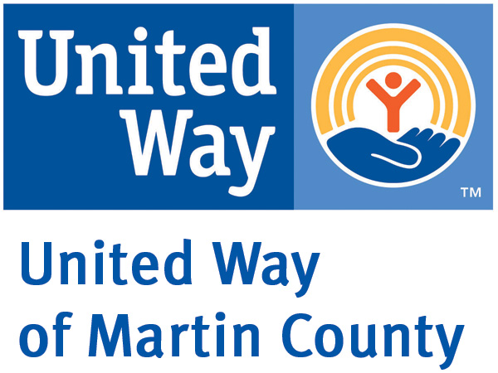

How to Transfer Stock

Thank you for your interest in making a charitable gift to United Way of Martin County in the form of a Stock Transfer.

Please initiate a "broker to broker" transfer using the following information:

- If your stock is held at a brokerage firm, direct your broker to wire transfer the shares to the United Way of Martin County, Inc.’s broker:

Susan D. Whittington
Morgan Stanley
729 S Federal Hwy
Suite 300
Stuart, Fl. 34994
(772) 283-7170 or 800-325-0038
Wire # MS DTC 0015
FBO United Way of Martin County Account # 517-107147-224

If you have possession of the stock certificate, in any denomination, take it UNSIGNED, to Cashier at Morgan Stanley. The cashier will arrange the transfer of the shares you are gifting and, if necessary, arrange for a smaller certificate for you. You will get a receipt.

- The amount of your charitable contribution is the mean price between the high and the low price of your stock on the day you made the gift.

- Please notify us of your intent to gift, as it may take several days for the transfers to be executed.

If you have further questions, please contact Theresa Schineis, Vice President of Finance at
(772) 283-4800, extension 2205.

Neither the United Way of Martin County, Inc. nor Morgan Stanley is engaged in rendering tax advisory services. For advice on specific cases, the services of a tax advisor should be obtained.

Thank you.

